Trees and Shrubs for Problem Landscape Sites: Overhead Utility Easements

Bonnie Appleton, Susan French and Brenda Johnson-Asnicar**

Trees are valuable assets in commercial, private, and public landscapes. Trees add aesthetic beauty, modify and enhance the environment, serve architectural and engineering functions, and increase property and community economic values. These same trees that enhance landscapes, however, are a major challenge for utility companies. Most people have grown accustomed to reliable, uninterrupted electric, telephone and cable service in their homes and offices. Unfortunately, trees are one of the major causes of power outages in areas of overhead utility lines due to direct tree contact with lines, or to limbs or trees falling on the lines.

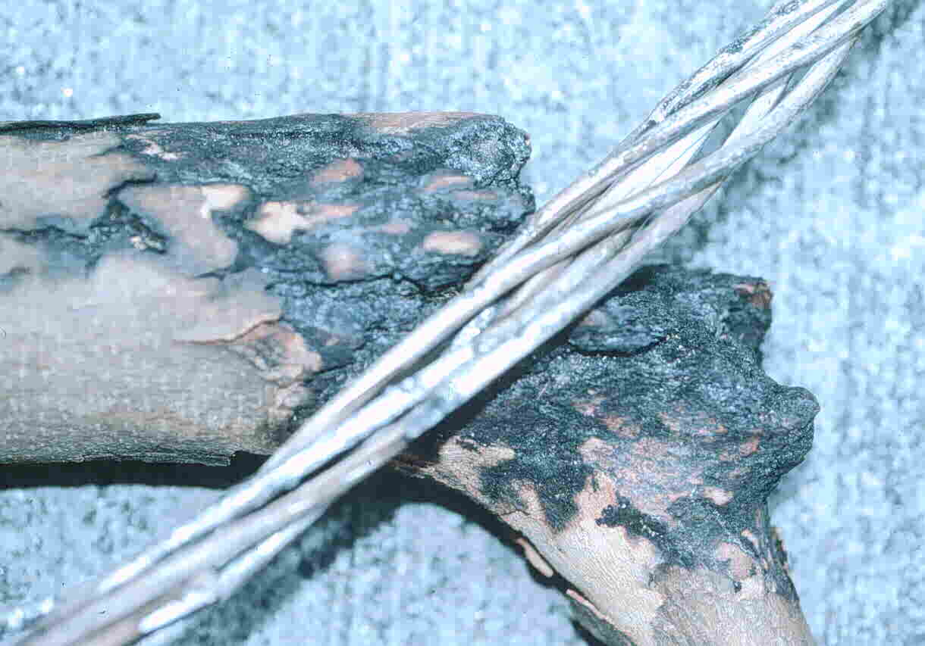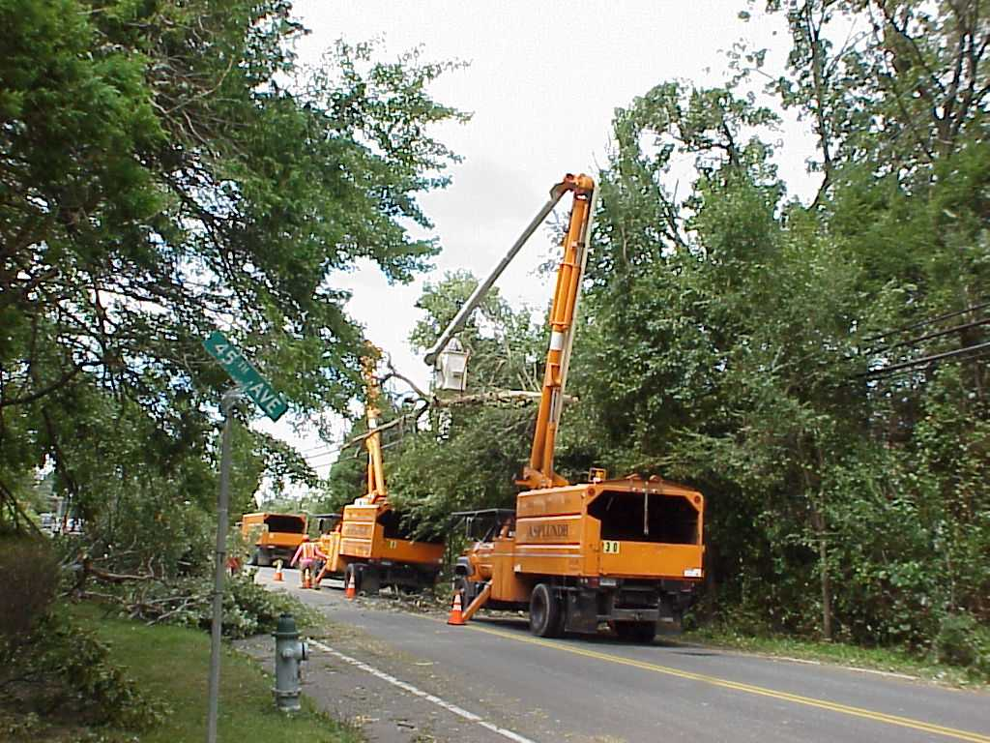

Tree limb burned by contact with utility wires Removal of limbs that have fallen on lines.

Whenever trees contact live wires they become conductors of electricity, causing power outages or creating dangerous situations for anyone coming in contact with the trees. Utility companies spend over $1.5 billion annually on labor and materials for tree pruning and removal. This maintenance work is necessary to protect the public and utility company employees who service the lines, and to insure safe, reliable electrical service. While we don’t want to risk losing this service, many of us dislike seeing trees removed or compromised in order to provide the service. The practice of planting tree species with inappropriately mature heights, or erecting utility lines where tall trees already exist, greatly increases these problems. Additionally, public relations problems that develop when the public is critical of the management of trees within these easements are an indirect cost incurred by the utilities.

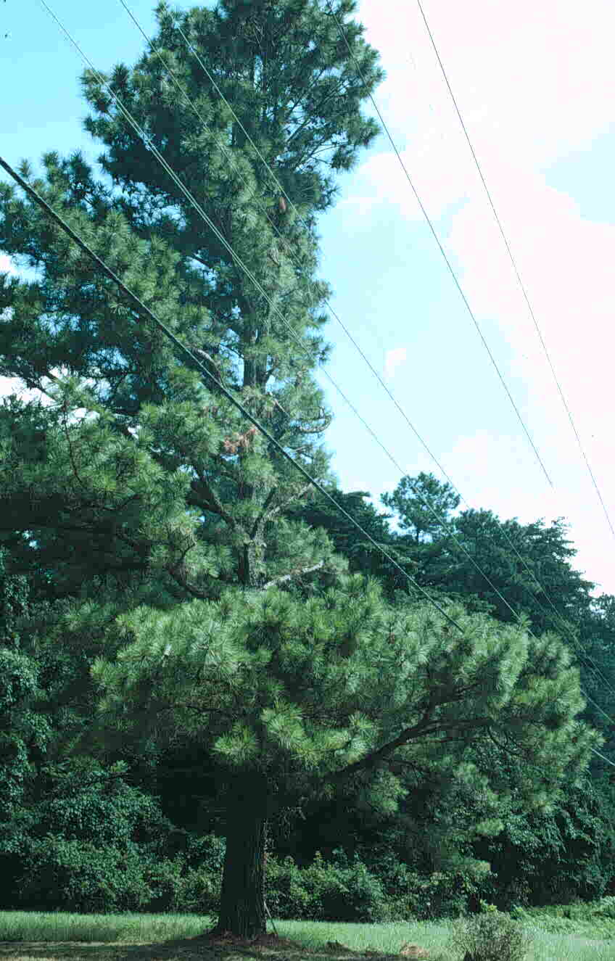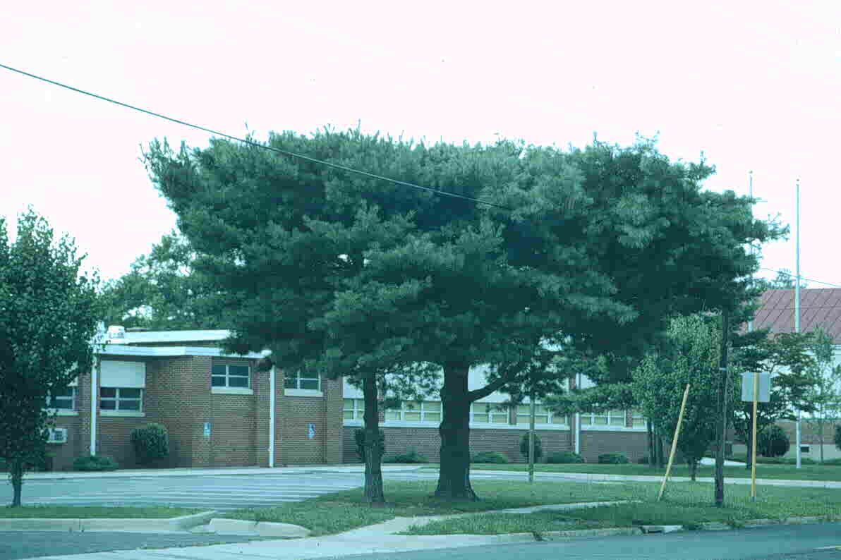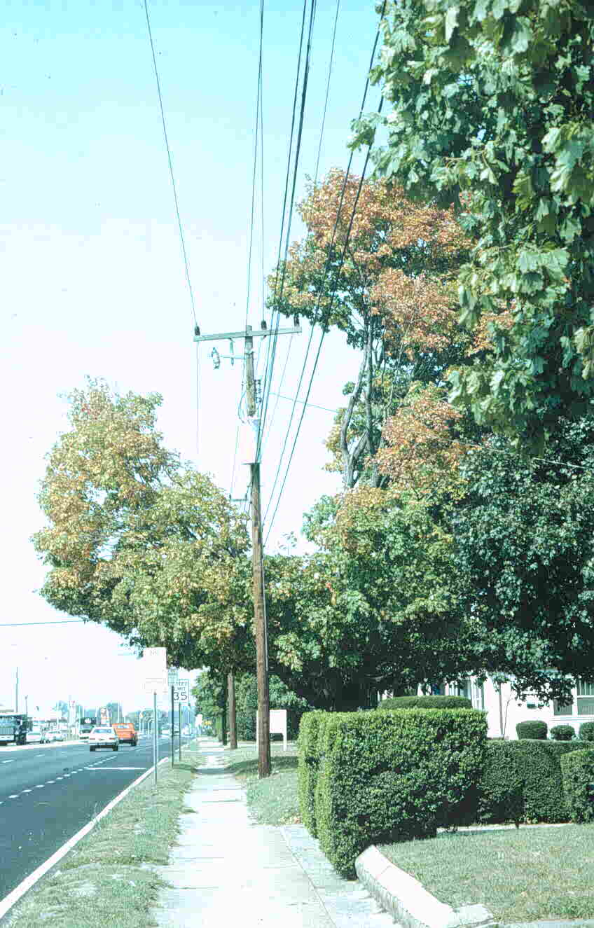
Misshapen tree canopies due to necessary line clearance pruning

Conflict Resolution Options

Line clearance methods for existing utility line/street tree conflicts, such as natural, lateral, and directional pruning, have been developed to minimize the impact of pruning on tree health. Unfortunately people often find this necessary pruning to be aesthetically unacceptable. Any line clearance pruning needed within easement areas should be carried out only by arborists trained in line clearance pruning, never by homeowners.

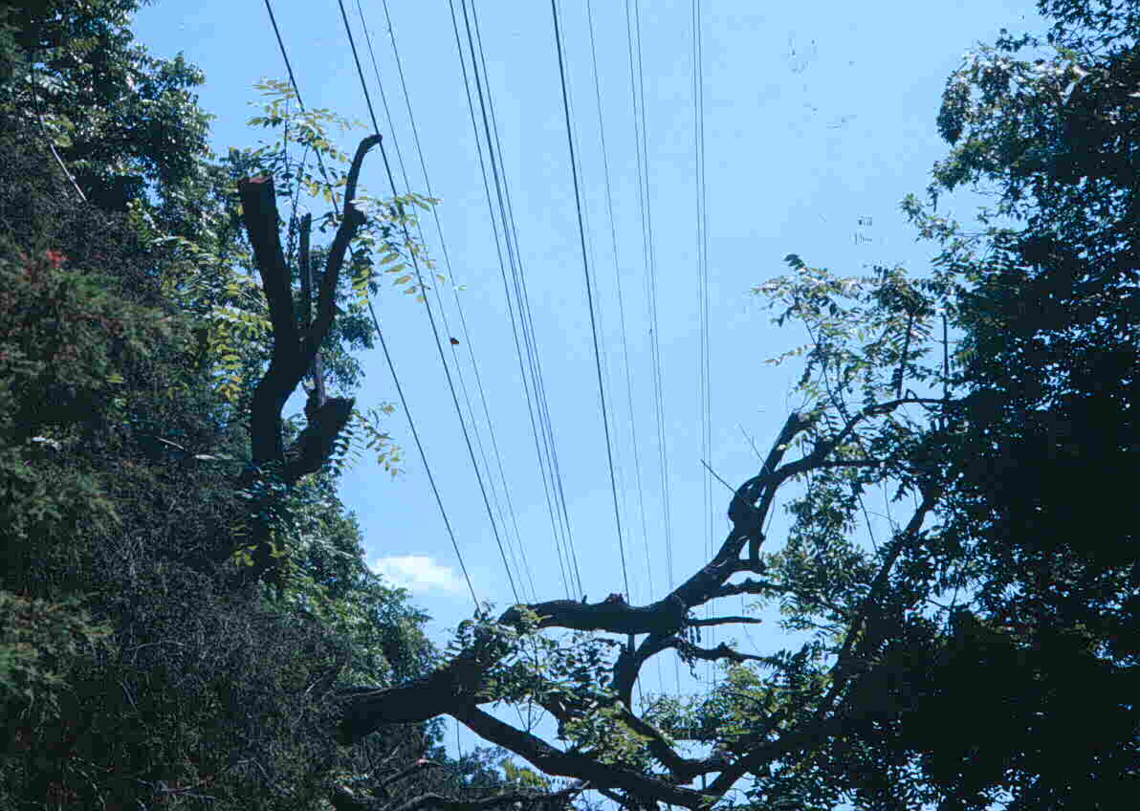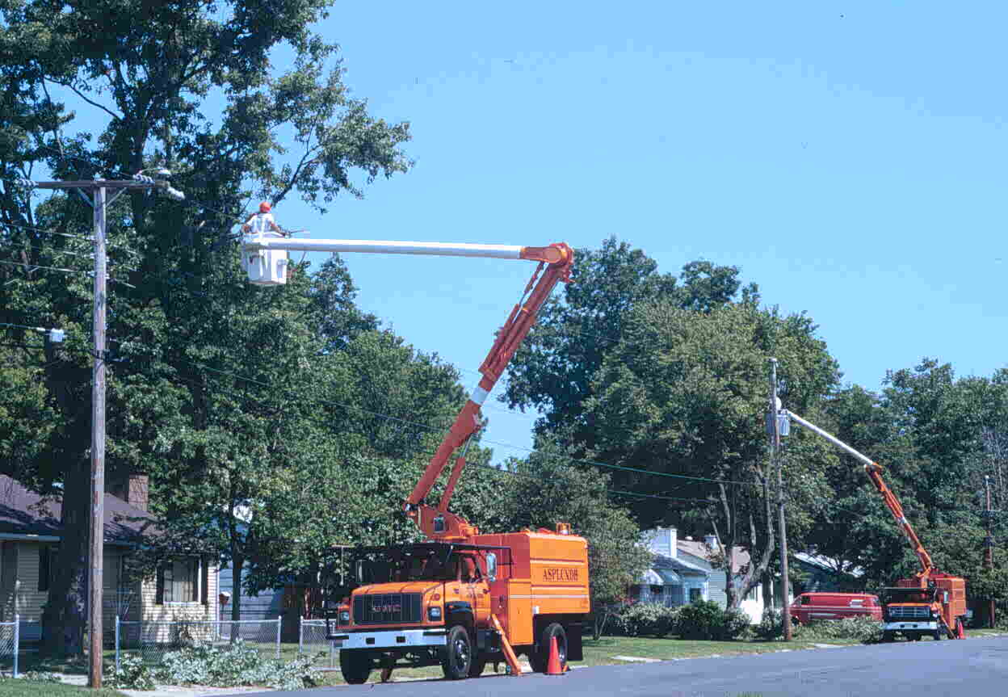
Directional pruning for line clearance Trained arborists removing limbs in utility easements

Additional options for dealing with utility line/street tree conflicts include the use of tree growth regulators, tree height control by pollarding, and initiation of tree pruning far in advance of tree-line interception. Each of these options tries to prevent future conflict situations but is still costly maintenance. Whole tree removal eliminates the conflict but negatively impacts the environment and community.

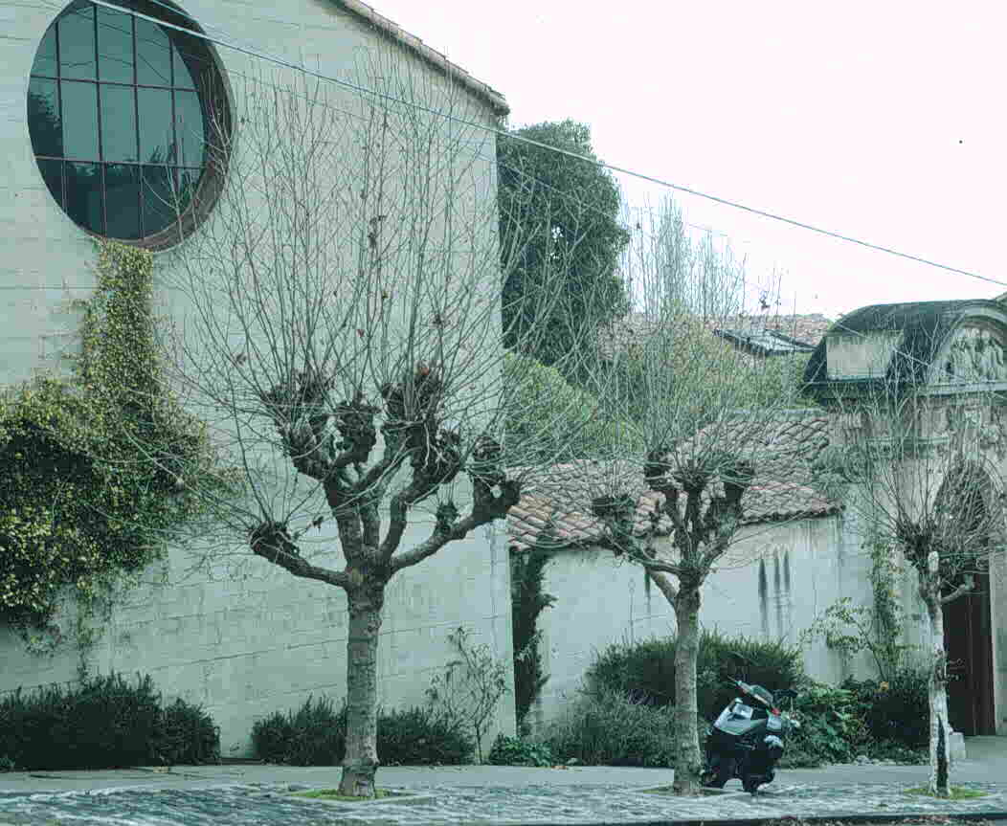

Large sycamore trees pollarded to keep them from infringing on utility lines

The best approach is to prevent street tree/utility line conflicts from arising in the first place. Where practical, new utility lines can be constructed to avoid potential conflicts with trees either by installing lines underground or routing lines to avoid existing trees. Selection of appropriately sized trees prior to planting is critical to the trees’ successful co-existence with overhead utility lines. This option is available to anyone involved with landscape design and installation - city planners, landscape designers and contractors, arborists, and private homeowners. Proper selection and planting of trees near overhead utility lines can improve the appearance of the landscape, prevent safety hazards, improve electric service reliability, and reduce line clearance expenses for utility companies and their customers.

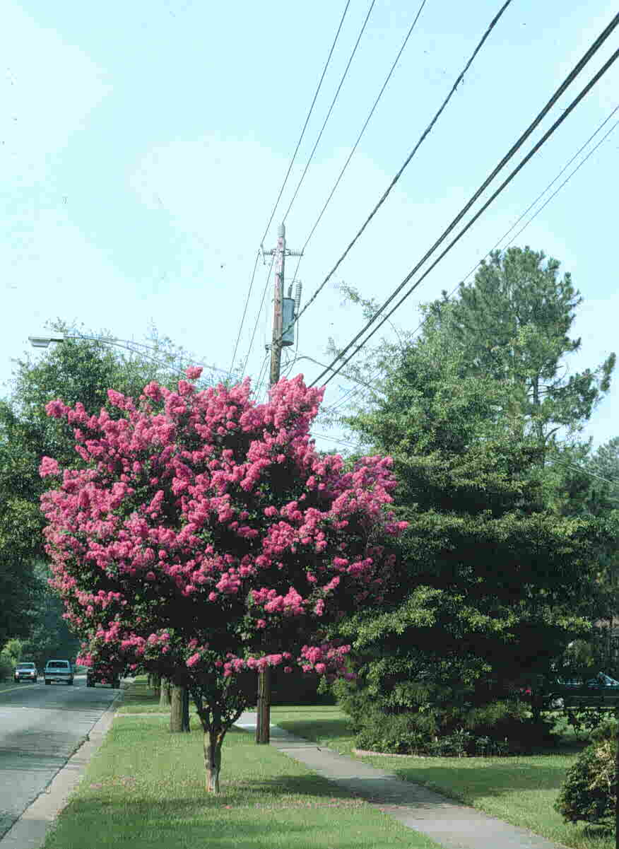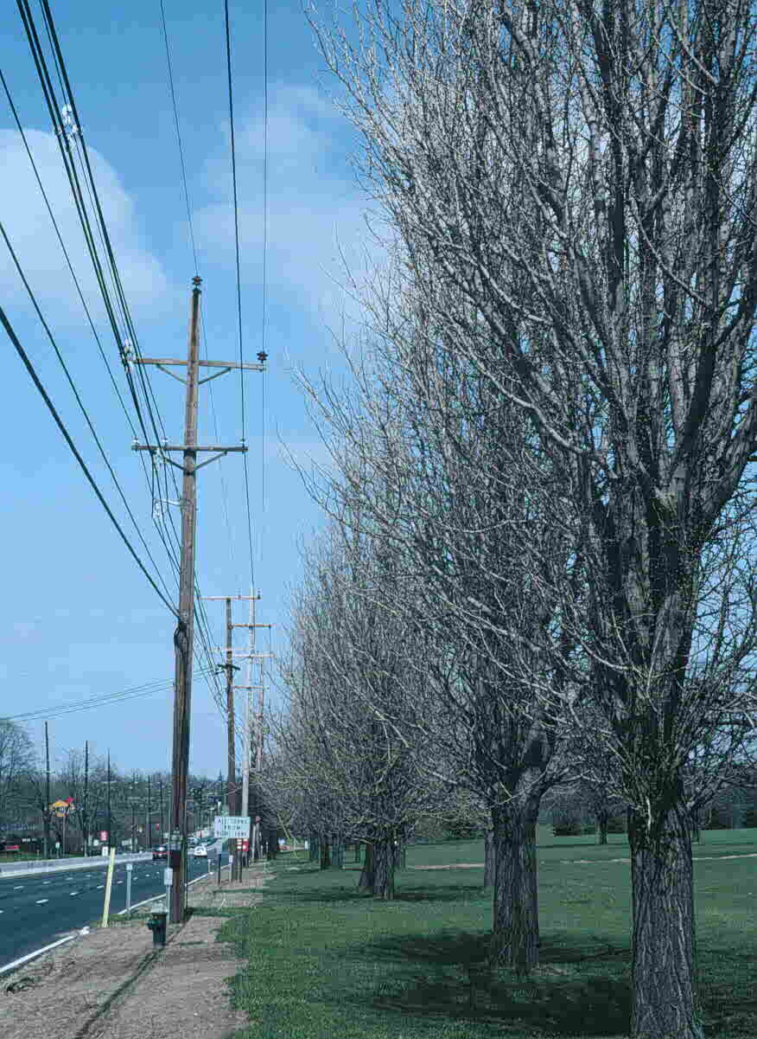

Crape myrtle, a large shrub or small tree Tall, upright trees can be planted along, but that can be used under overhead lines not never under overhead lines

Tree Selection and Planting

Before planting new trees, look overhead and all around the intended site. Note how far the tree- planting site is from overhead utility lines. For plant selection, determine whether the proposed planting site falls into a low, medium or tall tree height zone. The low height zone extends 15’ on either side of overhead wires. Plant large shrubs and small trees with mature heights of 20’ or less within this area. To account for the width of taller trees, the medium height zone begins at least 15’ from all utility lines and may include the area that frames a building or residence. Select trees that grow 40’ or less for this zone. The tall height zone begins at least 35’ from buildings and 65’ from utility lines. Tall trees need additional space to permit adequate root development and to minimize structural storm damage. Select trees that grow over 40’ for this area. Use tall trees in wooded lots, parks or other open areas where their height and spread can be appreciated without becoming a liability.

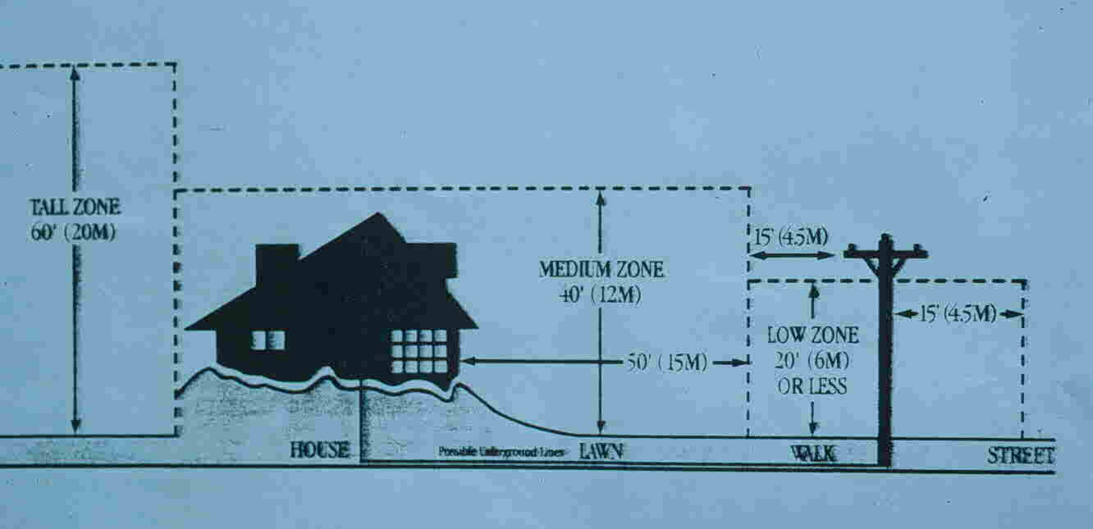

When selecting a particular tree species, consult a reference that will provide the tree’s mature height and spread. When selecting urban trees, avoid those that require high maintenance or drop messy fruits and leaf litter. Look for trees that can tolerate generally adverse urban conditions (limited soil volume and moisture, compacted soil, air pollution, etc.), and that have a slow to moderate (never fast) growth rate. Always follow proper tree and shrub planting guidelines (see VCE publication 430-295) and call MISS UTILITY (check your local phone directory) before you dig any planting hole.

At the Hampton Roads Agricultural Research and Extension Center in Virginia Beach, a Utility Line Arboretum showcases small trees and large shrubs for use in or near utility easements. By giving greater visibility to, and continuing to screen for, potentially appropriate trees and shrubs, the selection of plants with mature heights compatible with utility lines is improving.

When selecting “utility line” trees and shrubs, plant several different genera and species to avoid pest (insect and disease) and physiological (weather, chemical, etc.) problems that can easily kill off plantings of single species or cultivars (monocultures).

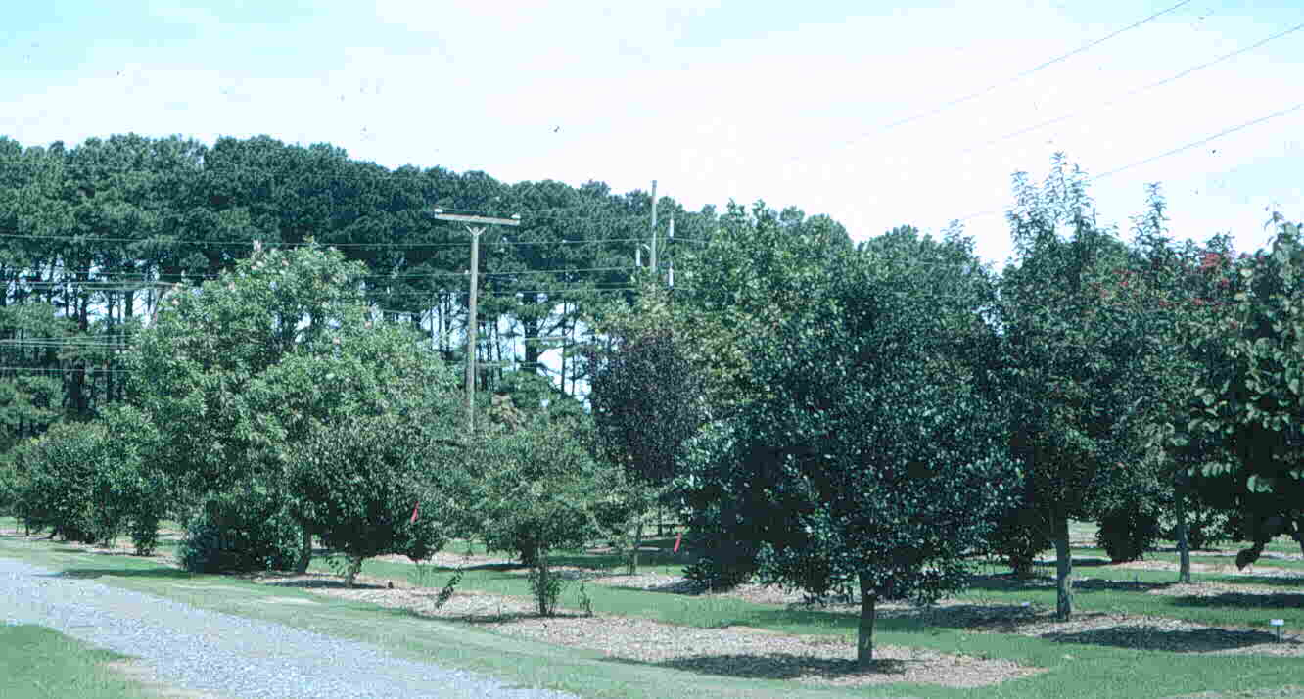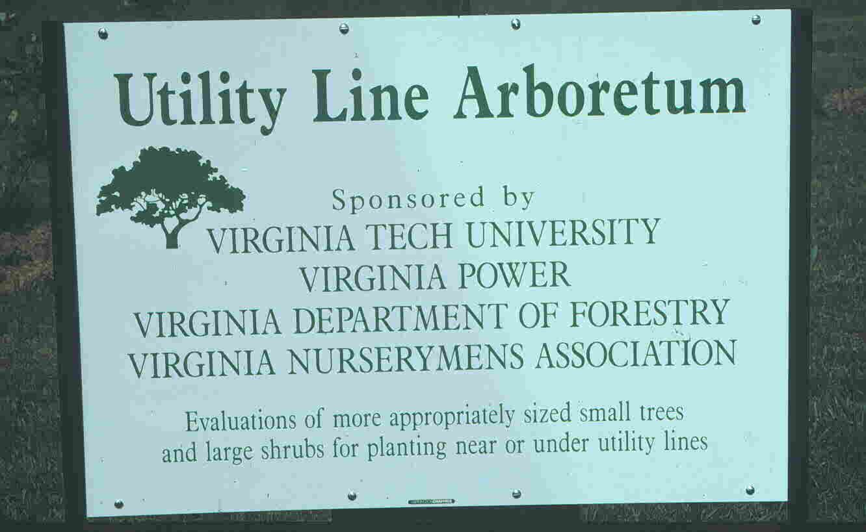
The Utility Line Arboretum at Virginia Tech’s Hampton Roads Agricultural Research and Extension Center
Under Utility Lines (trees that generally do not exceed 20’ in mature height, or that may need infrequent crown height reduction)

Common name Latin name Cold hardiness
Heat tolerance Ave. mature height

Amur maple Acer ginnala 2-7/7-1 15’-18’
Globe Norway maple Acer platanoides ‘Globosum’ 4-8/8-3 15’-18’
Serviceberries Amelanchier arborea, A. canadensis 4-9/9-4 15’-30’
Chinese fringetree Chionanthus retusus 6-8/8-5 15’-25’
White fringetree Chioanthus virginicus 5-9/9-5 10’-20’
Pagoda dogwood Cornus alternifolia 4-8/8-1 15’-25’
Cornelian cherry Cornus mas ‘Spring Glow’ 5-8/8-3 20’-25’
Leprechaun ash Fraxinus pennsylvanica ‘Johnson’ 4-9/9-1 15’-18’
Little Gem magnolia* Magnolia grandiflora ‘Little Gem’ 7-9/9-3 10’-20’
Saucer magnolia Magnolia x soulangiana 6-9/9-6 15’-25’
Star magnolia Magnolia stellata 5-9/9-5 15’-20’
Flowering crabapple Malus spp. 4-8/8-1 10’-30’
Cherry plum Prunus cerasifera ‘Thundercloud’ 5-9/9-4 15’-20’
Siebold viburnum Viburnum sieboldii 5-8/8-5 15’-20’

Under Utility Lines (large shrubs that can be pruned into tree form for use under overhear utility lines)

Common Name Latin Name Cold Hardiness
Heat Tolerance Ave. Mature Height

Althea/rose of Sharon Hibiscus syriacus 5-9/9-1 8’-12’
Crape myrtle* Lagerstroemia indica 7-9/9-7/6 10’-25’
Star magnolia Magnolia stellata 5-9, 9-5 6’-15’
Doublefile viburnum Viburnum plicatum var. tomentosum 6-8/8-6 6’-10’
Blackhaw viburnum Viburnum prunifolium 3-9/9-1 12’-15’
Chastetree Vitex agnus-castus 6-9/9-1 8’-15’

Near Utility Lines (trees that generally exceed 20’ in mature height; if used under easement will require more frequent pruning if planted in good growing location)

Common Name Latin Name Cold Hardiness
Heat Tolerance Ave. Mature Height

Trident maple Acer buergeranum 5-9/9-3 20’-25’
Hedge maple Acer campestre 6-8/8-4 25’-35’
American hornbeam Carpinus caroliniana 3-9/9-1 20’-30’
White redbud Cercis canadensis ‘Texas White’ 6-9/9-6 20’-30’
Kousa dogwood Cornus kousa 5-8/8-3 20’-30’
Stellar dogwood Cornus x rutgerinensis 5-8/8-3 20’-30’
Thornless cockspur hawthorne Crataegus crusgalli var. inermis 4-7/7-1 20’-30’
Washington hawthorne Crataegus phaenopyrum 4-8/8-1 25’-30’
Carolina silverbell Halesia diptera 5-8/8-4 30-40’
Goldenraintree Koelreuteria paniculata 6-9/9-6 25’-35’
Galaxy magnolia Magnolia x ‘Galaxy’ 6-9/9-6 20’-30’
Merrill magnolia Magnolia x loebneri ‘Merrill’ 5-9/9-5 25’-30’
Sourwood Oxydendron arboreum 5-9/9-4 20’-40’
Persian parrotia Parrotia persica 4-7/7-1 20’-40’
Chinese pistache Pistacia chinensis 6-9/9-6 30-35’
Flowering apricot Prunus mume 6-8/8-6 20’-25’
Okame cherry Prunus x ‘Okame’ 5-8/8-4 20-25’
Yoshino cherry Prunus x yedoensis 6-8/8-6 20’-40’
Flameleaf sumac Rhus copallina 4-9/9-3 20’-30’
Japanese stewartia Stewartia pseudocamellia 5-8/8-5 20’-40’
Japanese snowbell Styrax japonicus (esp. ‘Pink Chimes’) 6-8/8-6 20’-30’
Fragrant snowbell Styrax obassia 6-8/8-6 20’-30’
Japanese tree lilac Syringa reticulata 4-7/7-1 20’-30’

Near Utility Lines (tall trees that can be used near (but not under) utility lines due to their more upright and/or narrow crowns)

Common Name Latin Name Cold Hardiness
Heat Tolerance Ave. Mature Height

Norway maple Acer platanoides ‘Columnare’,
‘Crimson Sentry’, ‘Easy Street’, ‘Olmstead’ 3-7, 7-1 25’-45’
Red maple Acer rubrum ‘Armstrong’, ‘Bowhall’ 3-9/9-1 40’-50’
Sugar maple Acer saccharum ‘’Apollo’, ‘Newton Sentry’ 4-8/8-3 30’-50’
European hornbeam Carpinus betulus ‘Columnaris’, ‘Fastigiata’ 4-8/8-1 30’-50’
Ginkgo Ginkgo biloba ‘Fairmount’,
‘Fastigiata’, ‘Princeton Sentry’ 5-9, 9-2 40’-60’
Southern magnolia* Magnolia grandiflora ‘Alta’, ‘Hasse’ 7-9,9-3 40’-50’
Callery pear Pyrus calleryana ‘Capital’
‘Cleveland Select’, ‘Whitehouse’ 5-8/8-2 30’-40’
English oak Quercus robur ‘Fastigiata’,’Skyrocket’ 5-8/8-4 40’-50’

* Plants that, due to lack of cold hardiness, are not suitable for planting in all parts of Virginia (check your hardiness zone).

**Extension Specialist, Research Specialist, and Graduate Student, Hampton Roads AREC, Virginia Tech, respectively. Editorial contributions from Allegheny Power, American Electric and Dominion Virginia Power.

